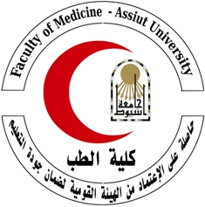

***Curriculum Vitae***

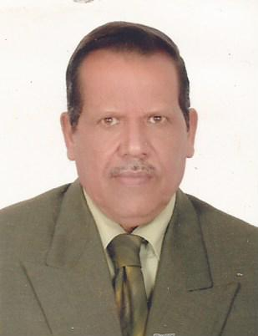**Personal information:**

**Name**: Ismaeil Seddik Mohamed Soliman.

**Gender:** Male.

**Date of birth:** October /20/1949.

**Citizenship:** Egyptian.

**Marital status:** Married.

**Last Degree:** professor doctor in Microbiology and Immunology department, faculty of Medicine, Assiout university.

**E-mail address:** ismailsoliman37@yahoo.com.

**Address:** Egypt, Assiut, 34 Mahmoud Rashwan str.

**Telephone Cellular:** 002-0100-3412279.

**Work:** 002-088-2411071.

**Fax:** 002-088- 2342708.

**Languages:**

**Arabic:** Mother language.

**English.**

**Education and Training:**

**FORMAL EDUCATION**

▪ **1955-1961 :** Primary School.

▪ **1962-1965 :** Preparatory School.

▪ **1966-1969 :** Secondary School.

**GRADUATION**

▪ **1972:** MBBCH; Faculty of veterinary Medicine, Assiut University, Assiut, Egypt; Very Good With Honor.

**Works:**

* Demonstrator in Microbiology and Immunology Department, Faculty of Medicine, Assiut University, Egypt : 1974.
* Assistant lecturer in Microbiology and Immunology Department, Faculty of Medicine, Assiut University, Egypt : **1978.**
* Lecturer in Microbiology and Immunology Department, Faculty of Medicine, Assiut University, Egypt : **1980.**
* Associate professor in Microbiology and Immunology Department, Faculty of Medicine, Assiut University, Egypt : **1984.**
* professor in Microbiology and Immunology Department, Faculty of Medicine, Assiut University, Egypt : **1989.**

**Publications :**

1-Shaban H. Ahmed1, Ismail S. Mohamed1, Mona A. Hassan1, Sherif I. Kamel2 and Aref M. Al-Hakimi1, PREVALENCE OF TRANSFUSION TRANSMITTED VIRUS (TTV) INFECTION IN PATIENTS WITH LIVER DISEASES ATTENDING TO ASSIUT UNIVERSITY HOSPITAL, Assuit Medical Journal , vol. (33), No (1), January 2009,, pp. 17-26, 2009

|  |  |
| --- | --- |
|  |  |

2-Nafie E., Seddik I., El-Timawi A., El-Feky MA., El-Sayed AA., Ehsan A. Hassan and Ring J., comparison between the effect of three different mitogens on lymphocytes from Egyptian and German Peoples. , Azhar. J. Microbiol. , NULL, Vol. 17, July, , 129-140., NULL, 1992

|  |  |
| --- | --- |
|  |  |

3-Nafie E., Seddik I., El-Timawi A., El-Sayed A., El-Feky MA., E Hassan and Ring J. , Response of lymphocytes isolated from German and Egyptian patients suffering from pollinosis to different types of pollen grain allergens. , Azhar. J. Microbiol. , NULL, Vol. 17; July, , 115-128., NULL, 1992

|  |  |
| --- | --- |
|  |  |

**Conferences and workshops :**

* The 20th Annual scientific Conference of the Egyptian Society of Infection control “Infection preventionists : Marathoning Towards Zero” , Faculty of Medicine, Cairo University, 17-20 October 2011.
* The 21st Conference of the Egyptian Society for Medical Microbiology “Antimicrobial Resistance : A Growing Health Issue” , Faculty of Medicine, Cairo University, 25 April 2015.

**Research Interests :**

After having my professor doctor degree, I planed to continue my scientific career in the field of molecular biology and to deepen my understanding of the molecular mechanisms for identification of bacteria and viruses.

Currently, I am looking forward for a research project that deals with new methods and for identification of bacteria and viruses.

I am a hard-working and determined person and i am ready for a new leap in my career. I will work hard in hope that the quantity of the effort I put in will result in high quality knowledge.

**Teaching Experience:**

* Demonstrator in Microbiology and Immunology Department, Faculty of Medicine, Assiut University, Egypt : 1974.
* Assistant lecturer in Microbiology and Immunology Department, Faculty of Medicine, Assiut University, Egypt : **1978.**
* Lecturer in Microbiology and Immunology Department, Faculty of Medicine, Assiut University, Egypt : **1980.**
* Associate professor in Microbiology and Immunology Department, Faculty of Medicine, Assiut University, Egypt : **1984.**
* professor in Microbiology and Immunology Department, Faculty of Medicine, Assiut University, Egypt : **1989.**

**Membership of Scientific Societies :**

* Egyptian Society of Microbiology and Immunology.

**Training Programs:**

* Effective communication skills.
* Legal aspects of universities.
* Thinking skills.
* Effective presentation skills.
* Exams systems and student assessment .
* The use of technology in teaching.
* Systems of credit hours .
* Research team management.
* Student assessment in medical education.
* Teaching methods in medical education.

**Computer Skills:**

Excellent general computer skills (International Computer Driving License).

**Awards:**

* **1973:** Certificate of honor and Assiut University Medal from Faculty of Medicine, Assiut univesity for MBBCH.
* **1978:** Certificate of honor and medal of Assiut univesity for appointed as a demonstrator in the faculty of Medicine.
* **1980:** Certificate of honor and the University symbol Award from Assiut univesity for M.D. degree.

**Activities:**

* Reading.
* Music and songs listening.
* Computer and Internet.
* Traveling.